Arlene Henderson’s Report
Having worked in Public Libraries for 18 years and suddenly finding myself facing redundancy, I decided to apply for one of the funded places offered by CILIPS Tayside to attend the CILIPS Autumn Gathering in Perth, I thought this would be a great opportunity to see all the other good things being done in other strands of the profession. I was delighted to have been awarded one and looked forward to the event. Leading up to the event I spent some time deliberating over which of the Breakout speakers I wanted to attend and I have to admit it was a tough choice as there were so many interesting speakers.
The day itself it began with lots of laughter as President Yvonne Manning (aka Humpty Dumpty) opened the event by introducing the brave few who had attended in fancy dress as their favourite nursery rhyme, followed by an interesting & passionate talk about Open Knowledge & Data by Catherine Stihler.
Then it was time for the first breakout session “Information Science at Think Analytics” which interestingly showed there were correlations between cataloguing and the work they do for TV companies. (The work that goes on behind the “If you liked this? Then we recommend this”)
Next up was a very entertaining and motivating session by AH Proctor – Why Libraries and Storytelling Matter, an avid supporter and user of public libraries all her life, it was wonderful to hear her talk about their importance and about her visits as an author to schools and libraries and the difference that they can make to children’s lives.
After lunch, Joseph Coelho told us all about his library marathon, he has taken on the challenge of joining (and borrowing from) all library authorities in the UK, another very passionate & lifelong user of libraries, we need more people like him and AH Proctor shouting out about our importance, particularly in areas of deprivation. Libraries are some of the last free places that are all inclusive and non-judgemental and we need to fight to preserve this despite the current climate.
Kindness was the theme of an afternoon breakout session and I think everyone who attended was left with a warm feeling after hearing of the steps taken at Glasgow University Library to make their spaces and services work better for their students and staff, and the fantastic things that have been happening in North Ayrshire with their programme Kindness Rocks! So very inspirational and again reinforced the benefits of libraries as welcoming places where all sorts can take place, from Ukulele and Samba classes, to learning to cook, brilliant work North Ayrshire I’m in awe!
Lastly Dr Sarah Morton asked “How do you know you are making a difference?” the difficulties of measuring how activities and programmes are achieving their goals, again very useful & interesting.
I had a brilliant day in Perth, met some lovely Librarians and most of all it reinvigorated me and my love of my profession, thank you for the opportunity.

Michael Charlton’s Report
The CILIPS Autumn Gathering always proves to be a great opportunity to network, meet new friends and catch-up with colleagues – and as a school librarian ‘flying solo’ day-to-day the opportunity to spend a day in the company of my fellow professionals is always difficult to resist.
The programme was packed full of fantastic speakers and choosing which talk to attend wasn’t always easy. But, before I talk about the wonderful breakout sessions and keynote speakers, we need to take time to congratulate the East & Central Branch committee members for their dedication to the cause – getting dressed up as fairy tale characters and looking absolutely fantastic.
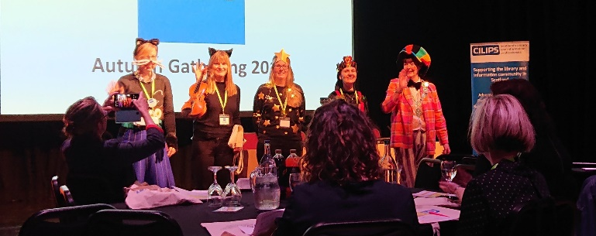
After a fantastic icebreaker of a welcome and introduction from CILIPS President Yvonne Manning (aka Humpty Dumpty), it was down to business with a great keynote from Catherine Stihler of the Open Knowledge Foundation. Catherine gave an inspiring presentation on how open data affects our democracy – and how libraries remain a central part of helping citizens access that data and stay informed.
The first breakout session was a great opportunity to spend time with fellow school librarians discussing the joys and the challenges of working in the education sector in Scotland. The “School Libraries Group Scotland Workshop - What should be our job description?”, led by Lee-Anne Connor (Chryston High School) and Amanda Green (The High School of Glasgow), provided a much needed space to compare and contrast the expectations, visions and realities of librarians, teachers and local authorities as we strive to provide literacy skills, safe spaces and a love of reading to Scotland’s young people.
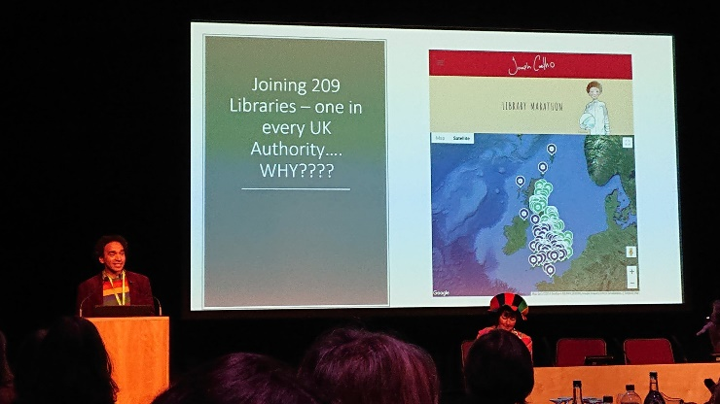
This theme ran into the second breakout session as Jackie Coroon shared her experience running ASN Reading Groups at a school in Aberdeenshire. It was heartening to hear how well received and supported Jackie’s work was – and the huge difference it made to the lives of the young people involved. I work with ASN pupils every day, both formally in the literacy lessons and informally in the various groups and extra-curricular activities I’m involved with. Jackie’s enthusiasm for her programme (alongside her evidence of impact) sent me rushing back to our English department to explore how our programmes can be revamped and improved.
Following the lunch break, author poet and all round nice guy Joseph Coelho told the assembled delegates of his mission to visit, join, and borrow a book from, a library in every local authority in the UK. Inspired to this ‘Library Marathon’ by his long standing love for, and respect of, libraries, hearing such a passionate and committed supporter of libraries certainly set us up for the afternoon.
And with the afternoon sessions came more opportunities to borrow great ideas from great school librarians. The “Instill Independent Learning - A Transitional Journey” session involved Laura Thomson, (Transition Teacher, Renfrew High) Robin Dunlop, (School Librarian, Renfrew High) and Sheila MacPherson (Liaison Librarian, University of the West of Scotland) discussing how they help Scotland’s young people during the difficult time of transitions they face; whether from primary to secondary school, or from secondary school to further and higher education. The potential for stress and emotional strain that these huge changes bring to the lives of young people is seen by those in the education sector year-in-year-out, and we are always looking to learn new and effective ways to help pupils.
In the final break-out session of the day Paul Morgan of Education Scotland introduced us to the newly created National School Libraries Professional Learning Community. The aim is to provide an online hub where school librarians, and those involved in school library provision, can interact, learn from each other and keep up to date on what is happening at Education Scotland as key policy documents such as the Scottish Government’s national school libraries strategy becomes embedded in schools.
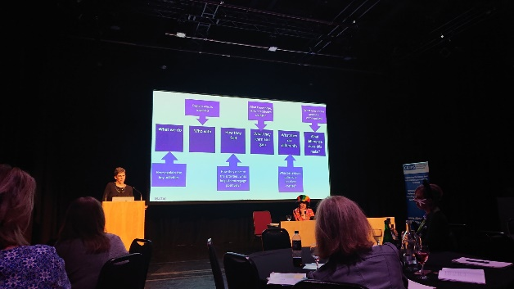
Finally, we reconvened in the main hall for the closing keynote. “How Do You Know If You Are Making a Difference? Evidencing and Telling Your Story” from Dr Sarah Morton (Co-Director of Matter of Focus) explored the difficulties of measuring the impact of programmes, activities and initiatives. But more importantly, gave us ideas on how to overcome these difficulties; an important skill to have in our toolbox as we go forward into an uncertain future.
The gathering had, however, left me feeling far from uncertain. It had been a fantastic day and I had met with so many passionate, innovative and driven professionals that I left enthused and ready to face the challenges ahead. Thank you to CILIPS Tayside for the opportunity to be part of the Autumn Gathering 2019.

