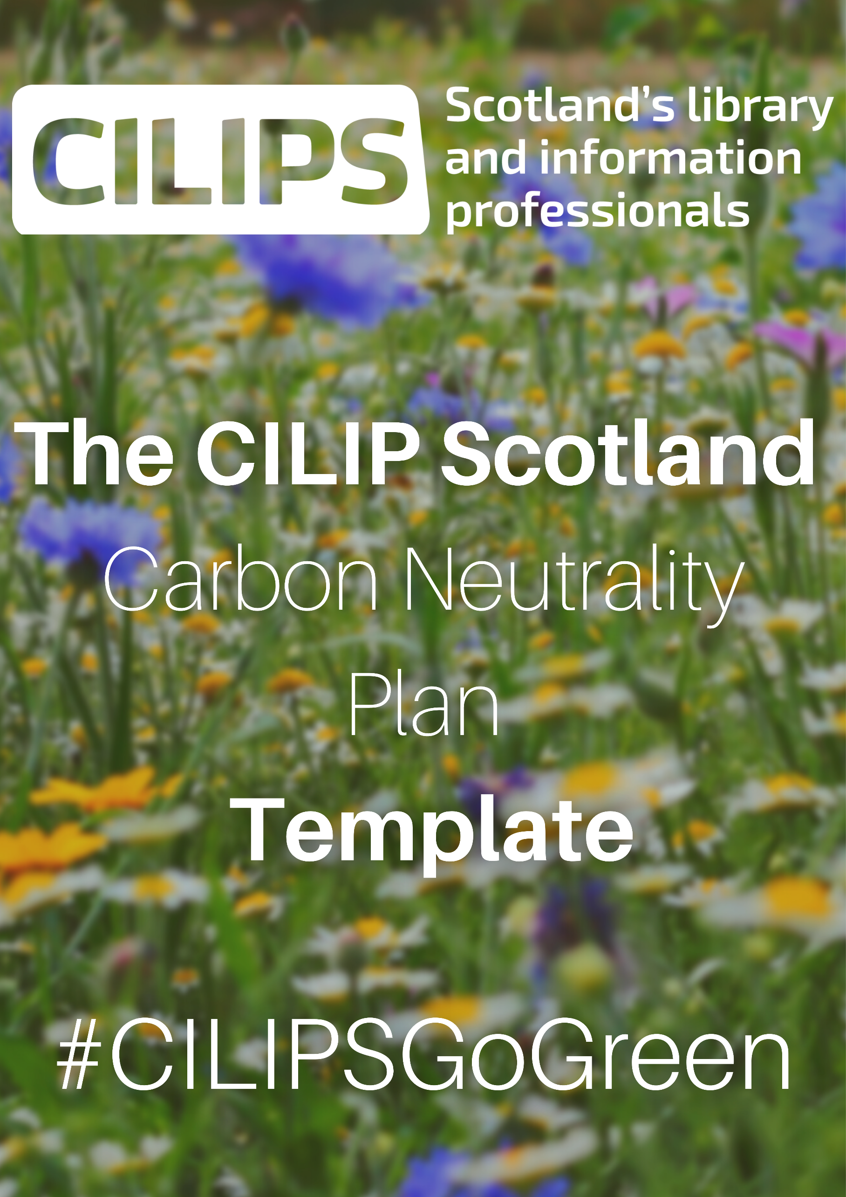
As a starting point, we needed to know exactly what the current CILIPS Carbon Footprint looks like and used two freely available calculators to assess this: one from the World Wildlife Fund for individuals and one from the Gallery Climate Coalition, specifically for GLAM sector organisations. Key points from the WWF calculator included:

- Food - whether at work or at home, Carbon Footprints are reduced by vegan/vegetarian locally produced food and increased by takeaways, imported items and high levels of food waste.
- Travel - private vehicle use exacerbates Carbon Footprints (although the size and fuel type of vehicle are also important) and a priority is minimising commuting time overall. Flights in particular increase Carbon Footprints and a priority is to minimise them/reduce their impact by financial carbon offsetting as a last resort.
- Space - in a home or office environment, issues to consider include the number of rooms, how they are heated and the baseline temperature, as well as whether electricity is provided by a company with a green tariff. Technology should be turned off, not left on standby during non-use. Small changes that can improve Carbon Footprints include energy saving lightbulbs, double glazing and low flow taps.
- Equipment - buying new mobiles/laptops/appliances has a detrimental impact on Carbon Footprints, with improvements possible through recycling and/or composting.

While not all the points of the Gallery Climate Coalition calculator are relevant to CILIP Scotland operations (e.g. in contrast to art galleries and museums, we very rarely need to package and ship large items), it helpfully reinforced the importance of reducing travel (especially private travel) to improve our Carbon Footprint and even calculated exactly what the carbon impact of any given mode of transportation would be.

- Travelling by train to the CILIPS office once a week creates 0.02 tons of Carbon Emission in a year (tCO2e), while travelling to and from our Annual Conference in Dundee by train equates to 0.01. Interestingly, this is equal to the tCO2e produced if a person travelled the 80 miles by car (0.01 tCO2e) but purchasing a tank of fuel beforehand increases the total impact of the car journey to 0.09 tCO2e. As an organisation, this means that if 150 delegates purchase a train ticket to attend one of our events (for simplicity, assuming an average cost of £20 per ticket) the impact equates to 0.26 tCO2e. If 150 delegates all attended by car, however, the carbon impact would be at least 13.5tCO2e.
- Compared with electricity use, analysis by the University of New South Wales suggests that a hypothetical Zoom meeting with 1000 participants for 1 hour generates a maximum of 37.125KWh, creating 0.01 tCO2e. By our own calculations, 100 participants for 7 hours (x 2 for two conference days) therefore equates to no more than 51.8KWh, still creating 0.01 tCO2e according to the Gallery Climate Coalition calculator.
- If we print a low-weight paper item like our conference programme 200 times, this results in 0.02 tCO2e.

Over the following pages, you will find templates based on the three main aims of the CILIPS Carbon Neutrality Plan (Events and Meetings, Travel and Resource Use), which you can customize with actions, progress measures and required resources that are relevant to your own organisation.

Find out more about our ongoing library sustainability work in Scotland by visiting #CILIPSGoGreen.

Action Plan Aim 1: make our events and meetings carbon neutral
Collaborators:

Specific Actions | Measure of Progress | Resources Required | Timeline | Status

Action Plan Aim 2: make our travel carbon neutral
Collaborators:

Specific Actions | Measure of Progress | Resources Required | Timeline | Status

Note on travel: At a recent ‘Exploring the Climate Crisis at the National Library of Scotland’ workshop (online, 08/12/21), it was highlighted that transport accounts for 35.6% of Scotland’s carbon emissions.

Action Plan Aim 3: make our resource use carbon neutral
Collaborators:

Specific Actions | Measure of Progress | Resources Required | Timeline | Status

